End-to-end NLP Project Implementation

This project was built by referring to the YouTube video by Codebasics.

In this video, we will build a chatbot in Dialogflow for a food delivery system. It will be an end-to-end project covering Dialogflow basics, building a backend in python and Fastapi, interactions with MySQL database, and much more. We will cover Dialogflow fundamentals such as intents, entities, contexts, etc.

Project steps:

00:00 - 01.53: Introduction

01.54 - 4.23: Problem statement

4.24 - 10. 00: Scope of Work

10.01 - 12.23: Using ChatGPT for Solution Design & Architecture

12.24 - 14.00: Finalizing Chatbot Building Steps

14.00 - 17.14: Reason for choosing DialogFlow

17.30 - 20.27: Dialogflow setup

20.28 - 24.16: Dialogflow intents

24.17 - 28.09: Dialogflow entities

28.10 - 52.45: Dialogflow setup

52.46 - 01.04.48: Dialogflow contexts

01.04.50 - 01.06.22 : Fulfillment

01.06.23 - 01.10.14 : Database setup

01.10.15 - 01.15.10 : Backend setup

01.15.11 - 02:24:48: FastAPI Python Backend coding

02.24.49 - 02.49.38 - Website integration

Detailed project workflow:

Create an account on dialogflow using google account and start new agent. We have named the agent as “Sira-food-delivery-chatbot”. SIRA stands for “Savvy Interpretation and Recognition application”, where savvy means smart, it comes from a French phrase – “Savior Faire” which means “know-how / he knows”.

Create new intents (new.order, track.order, etc) and entities (food-item) in this agent. Use the training_phrases file given in dialogflow assets to create intents. In track.order intent, rename the number entity as order-id. Similarly in track.order-context, rename the number entity as order-id.

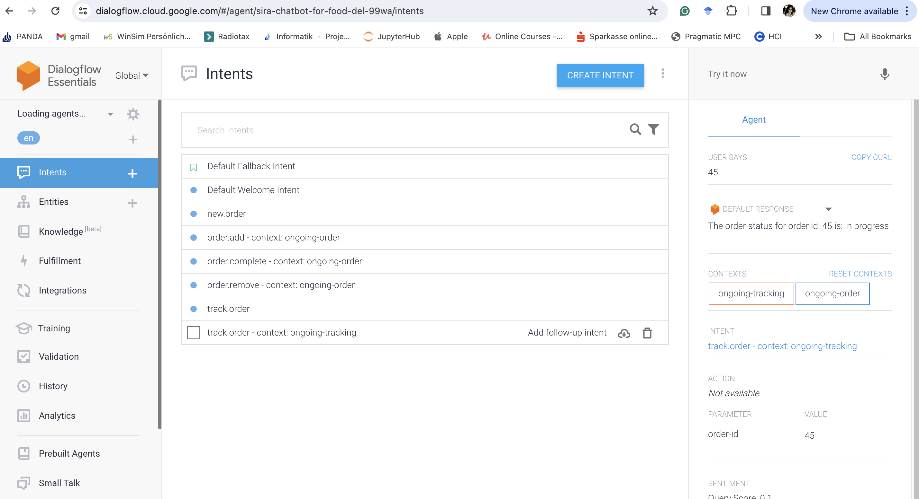

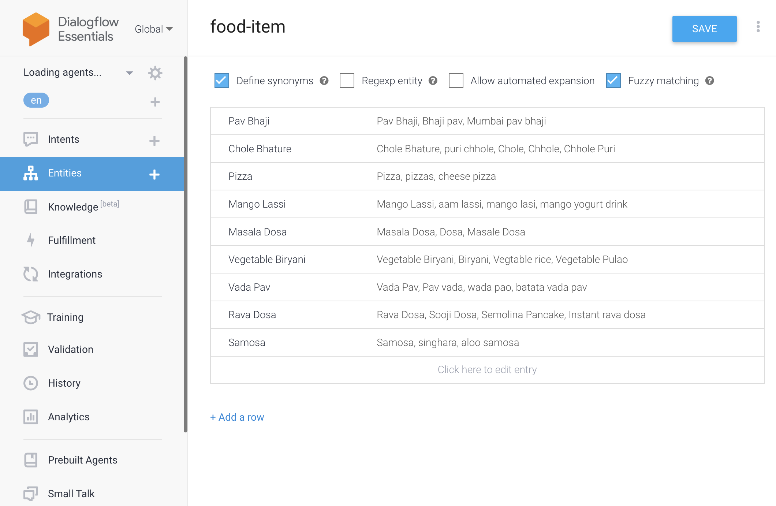

Create a fastapi connection using Python script in Pycharm

Type in terminal these commands:

Pip install fastapi

Pip install uvicorn

Create a main.py file:

from fastapi import FastAPI  
from fastapi import Request

app = FastAPI()

@app.get("/")

async def root():  
 return {"message": "Hello World"}

Run the main file using command:

uvicorn main:app --reload

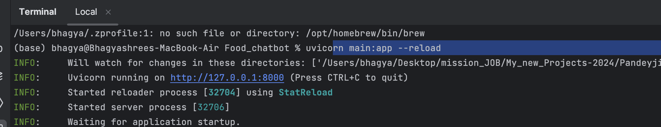

Terminal window:

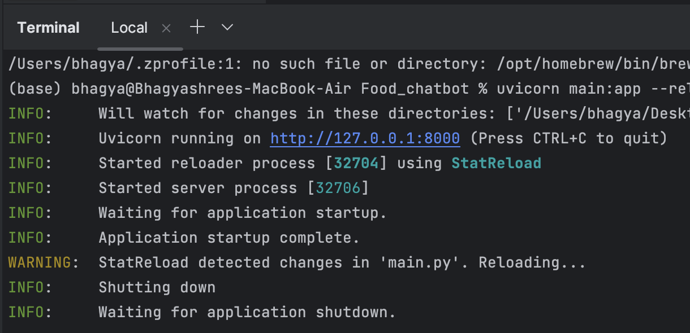

Click on <http://127.0.0.1:8000> and check if the hello world message is received. With this, it can be confirmed that the connection between pycharm and fastapi is established.

Navigate to the Fulfillment tab on Dialogflow and enable the “Webhook” button.

Now, add this url in the fulfillment tab of Dialogflow.

It throws error as url should be “https” – secure connection

Navigate to ngrok console in the browser and create an account

After the account is created, open a terminal in the same project directory.

The project directory is “Desktop/mission_JOB/My_new_Projects-2024/PandeyjiChatBotCodebasicsProject/”

Command to install ngrok

brew install ngrok/ngrok/ngrok

Run the command

ngrok http 8000

The ngrok terminal will open and close throwing error ‘unable to authenticate. Please create an account to authenticate on ngrok.’

Command to authenticate ngrok

ngrok config add-authtoken 2dFQUmmnN5DYWkR38LURCimG2MW_63VXuzPKiBZ5mpHSNHm5s

After adding authentication token, type ngrok http 8000 (Sometimes you need to restart the terminal to apply changes)

Ngrok provides a secure tunnel for the given url

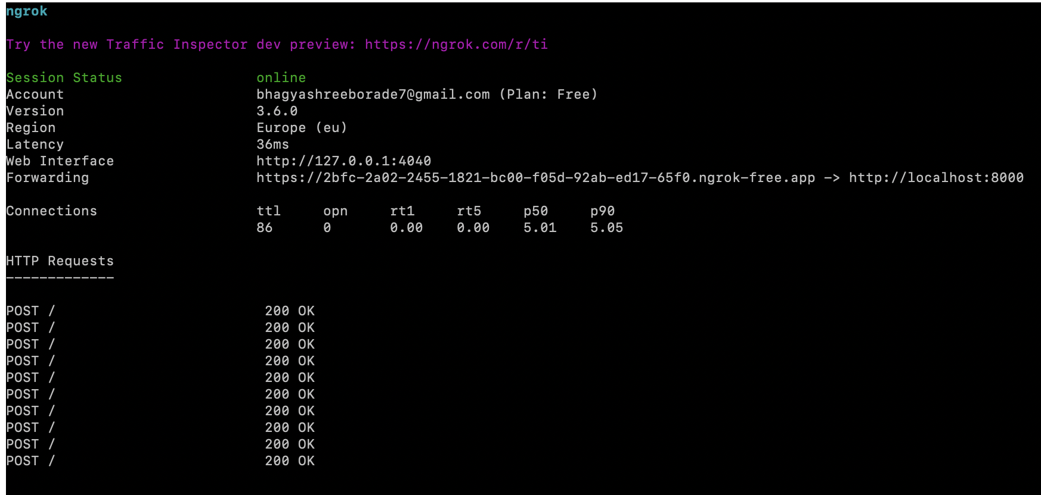

In this case, the new url is <https://2bfc-2a02-2455-1821-bc00-f05d-92ab-ed17-65f0.ngrok-free.app>

Now add this link to the fulfillment tab in Dialogflow and save it. (No need to add other details)

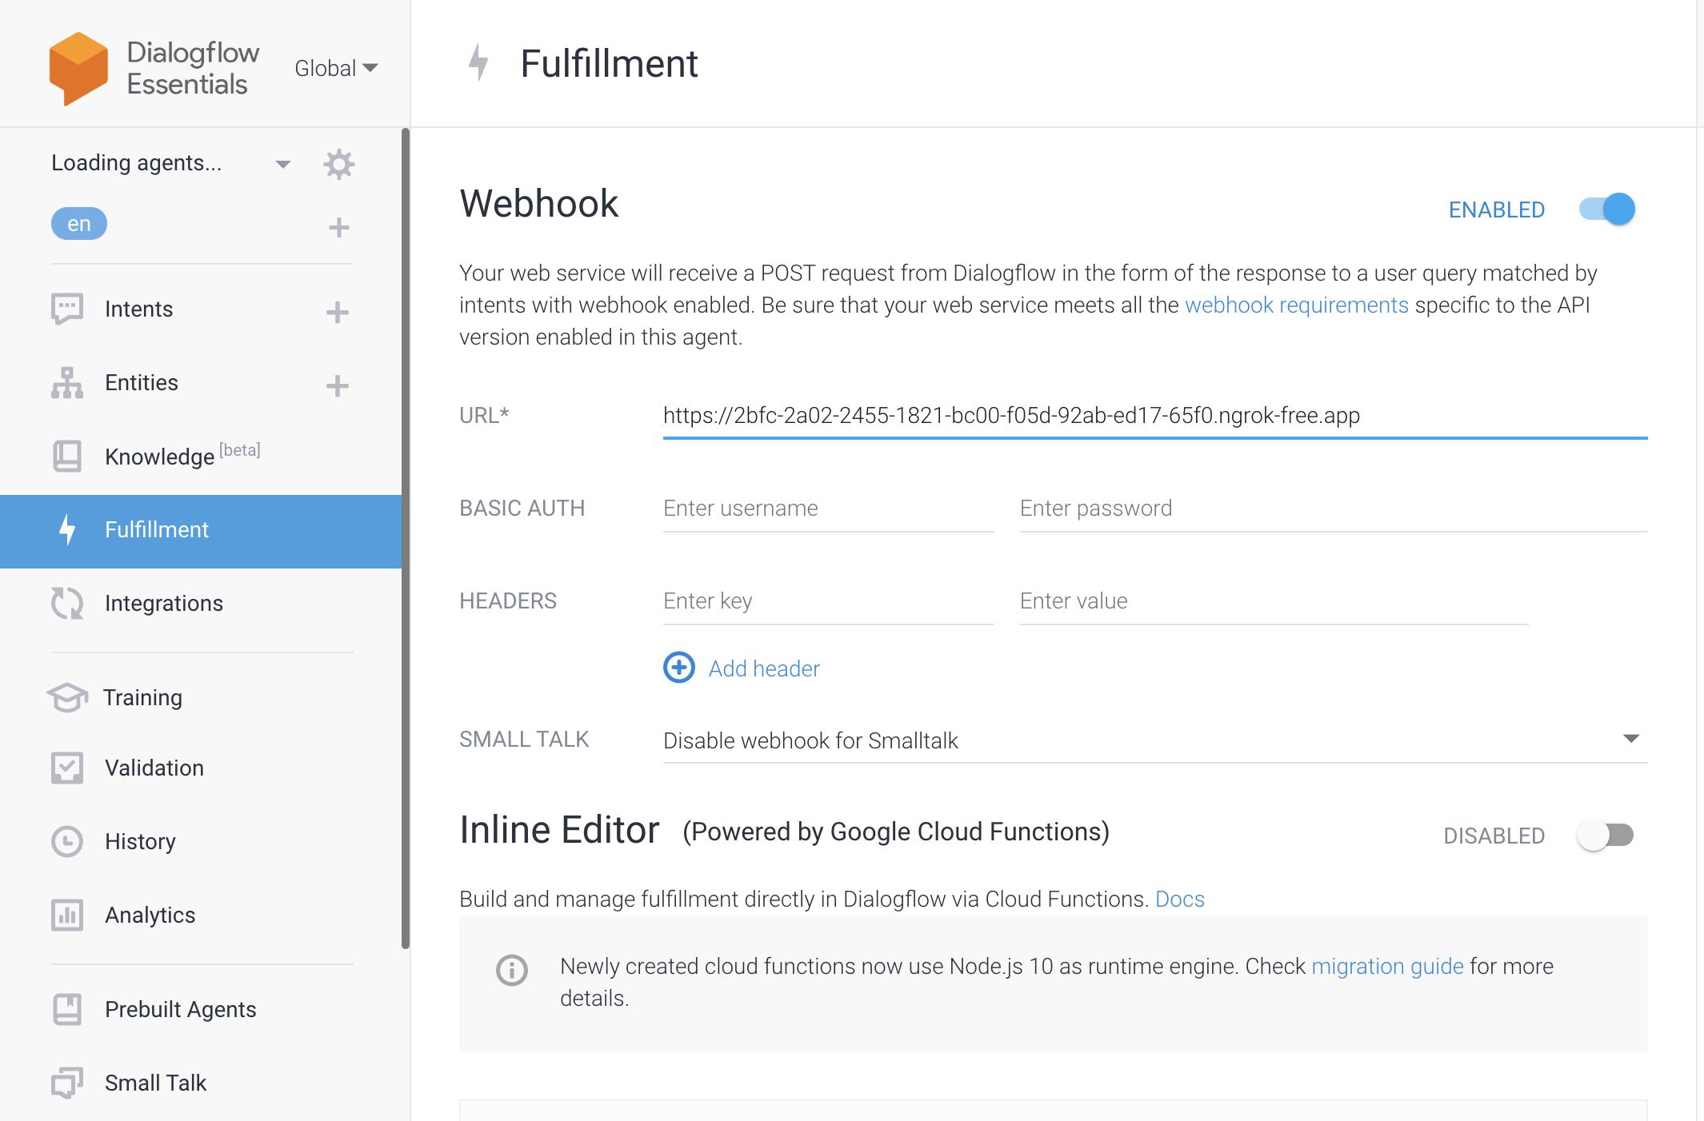

This implies that the Dialogflow is successfully connected to Pycharm via fastapi.

Now, download mysql workbench and create an account, as well as download mysql community server.

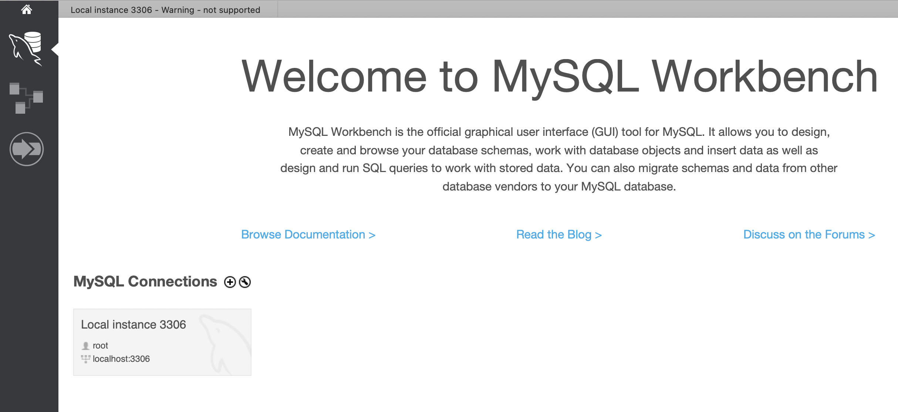

While installing, the server will prompt for username and password.

(user: root, password: Bhagya@19)

Click on Local instances 3306 tab and import the database given in “/Users/bhagya/Desktop/mission_JOB/My_new_Projects-2024/PandeyjiChatBotCodebasicsProject/db”

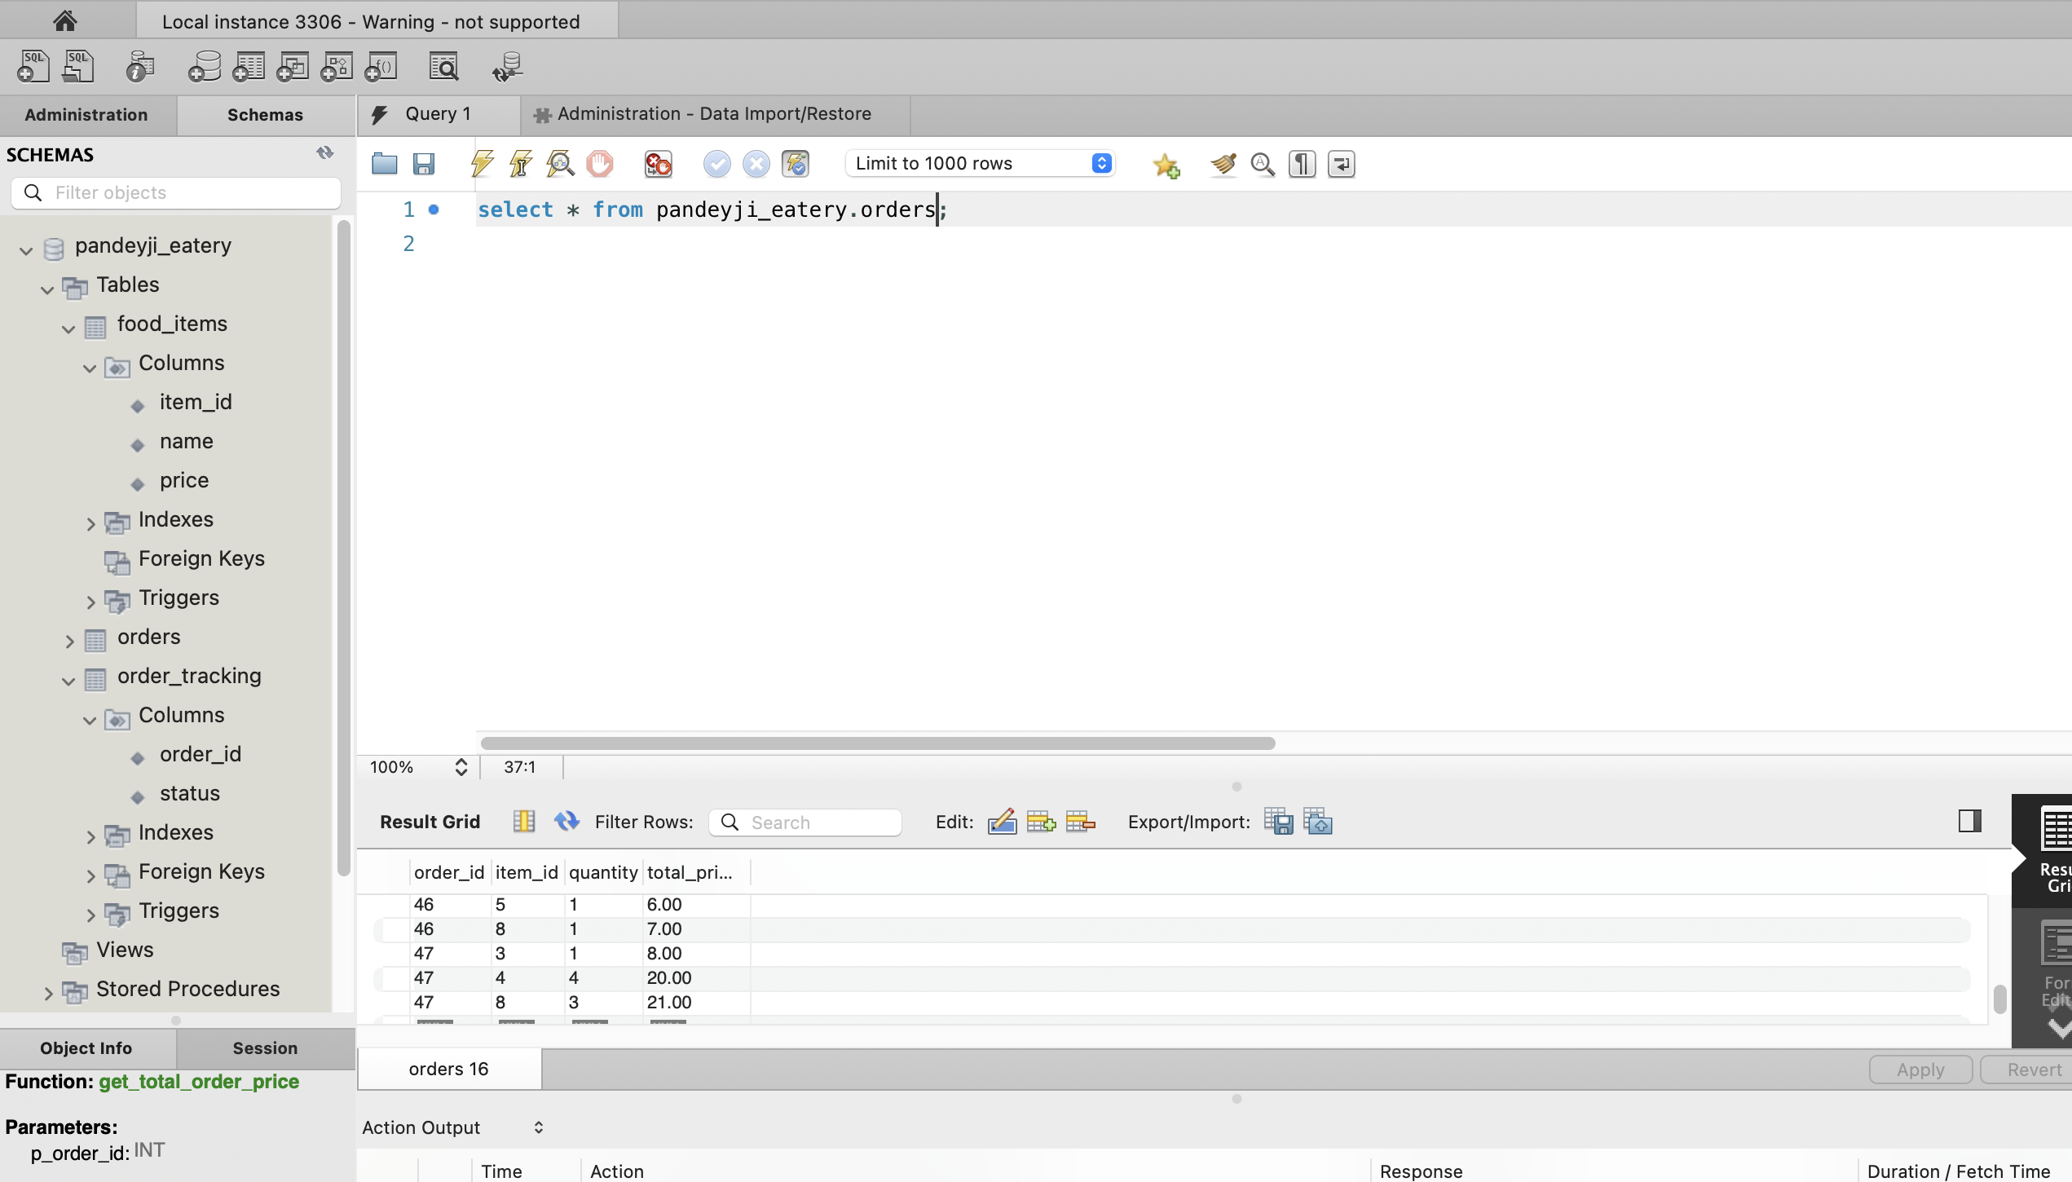

Create a db_helper file to establish connection with this database

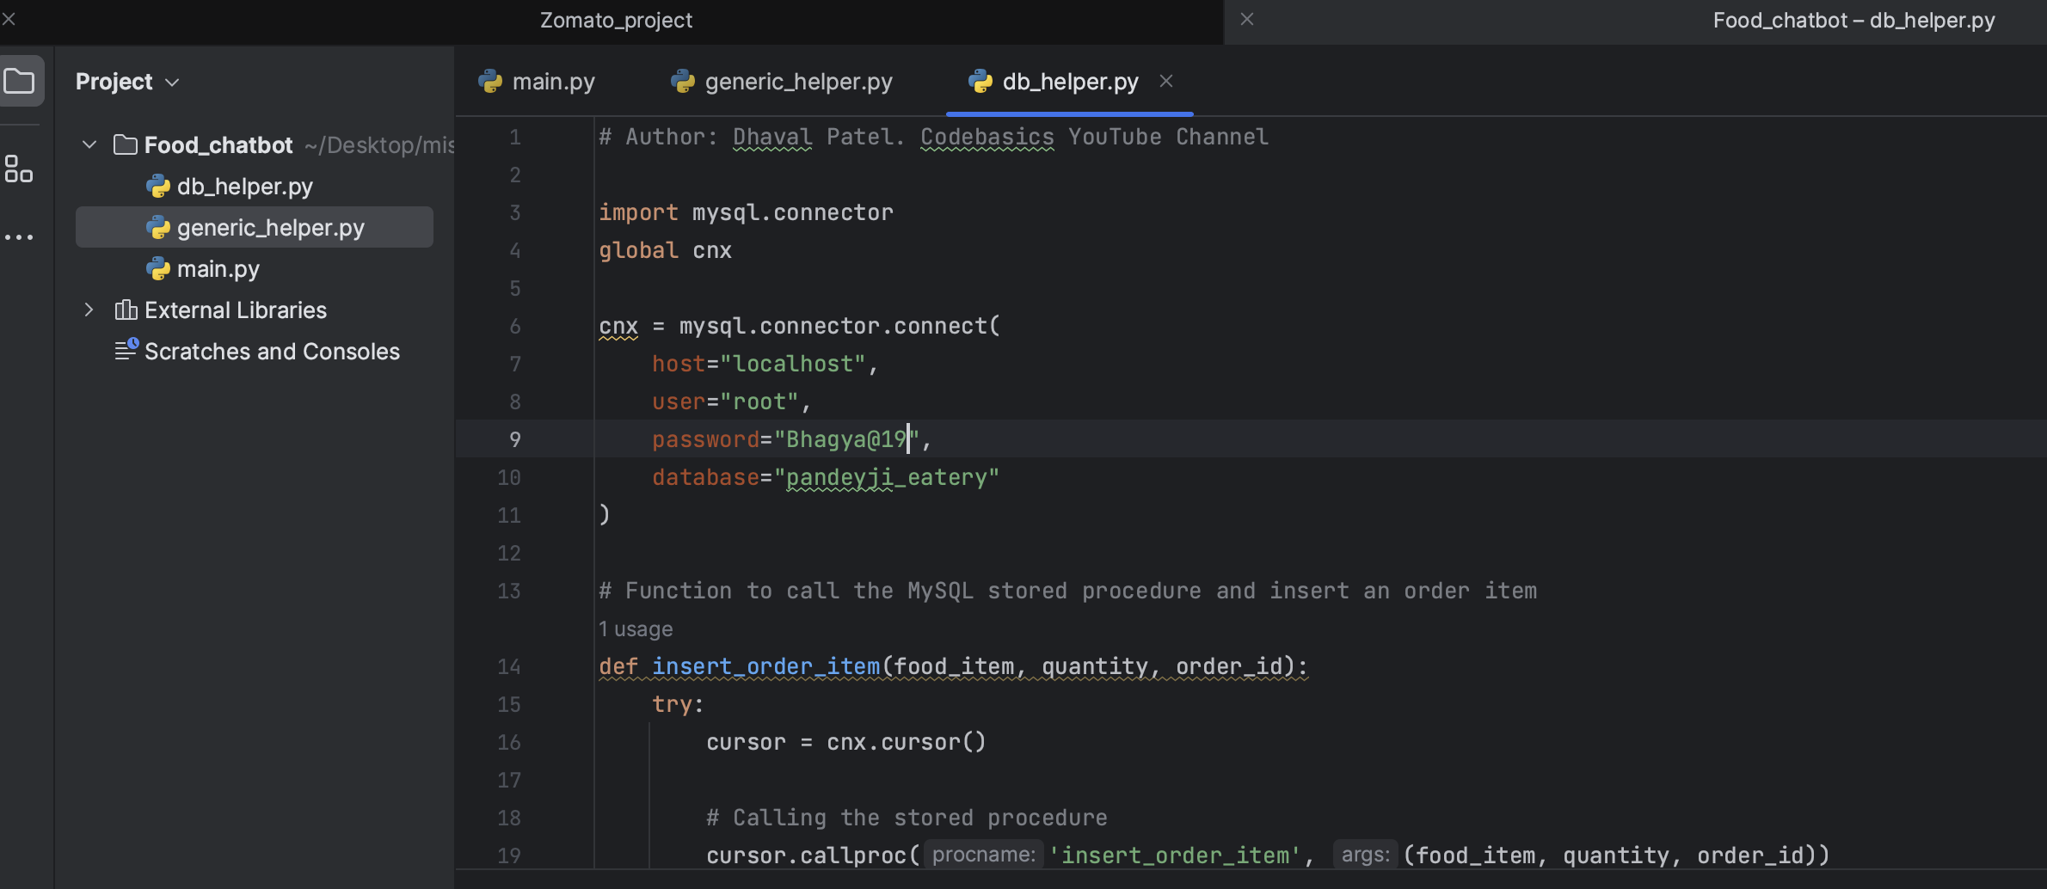

Use the python files given in the project folder(db_helper, main, generic_helper) to work further.

Enable the webhook call button in the intent to extablish connection with python script

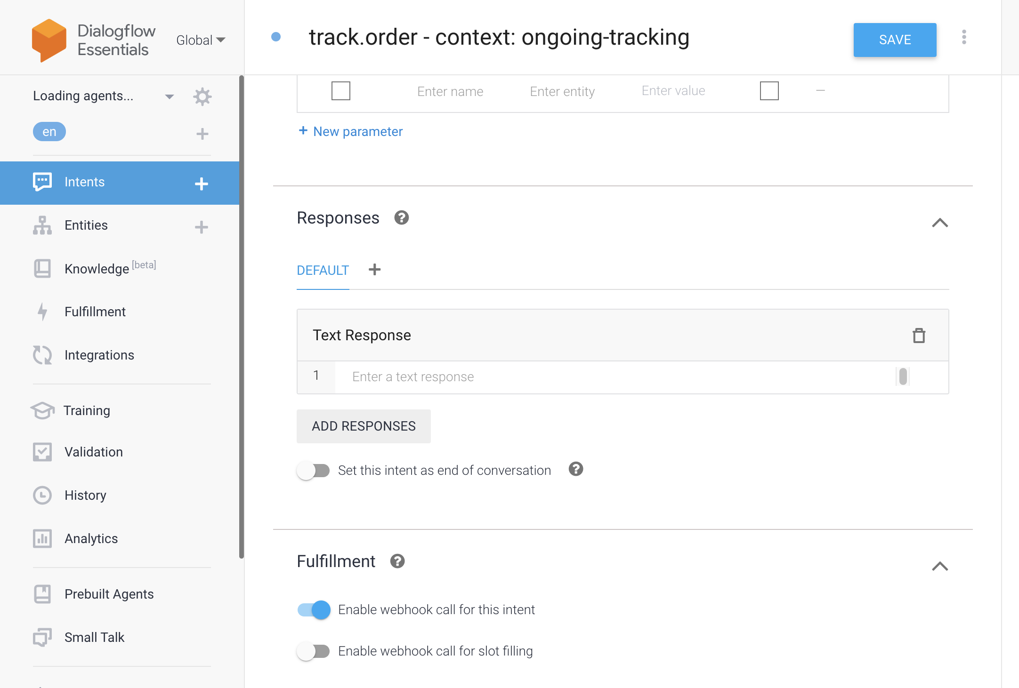

Navigate to the Integrations tab and enable web demo.

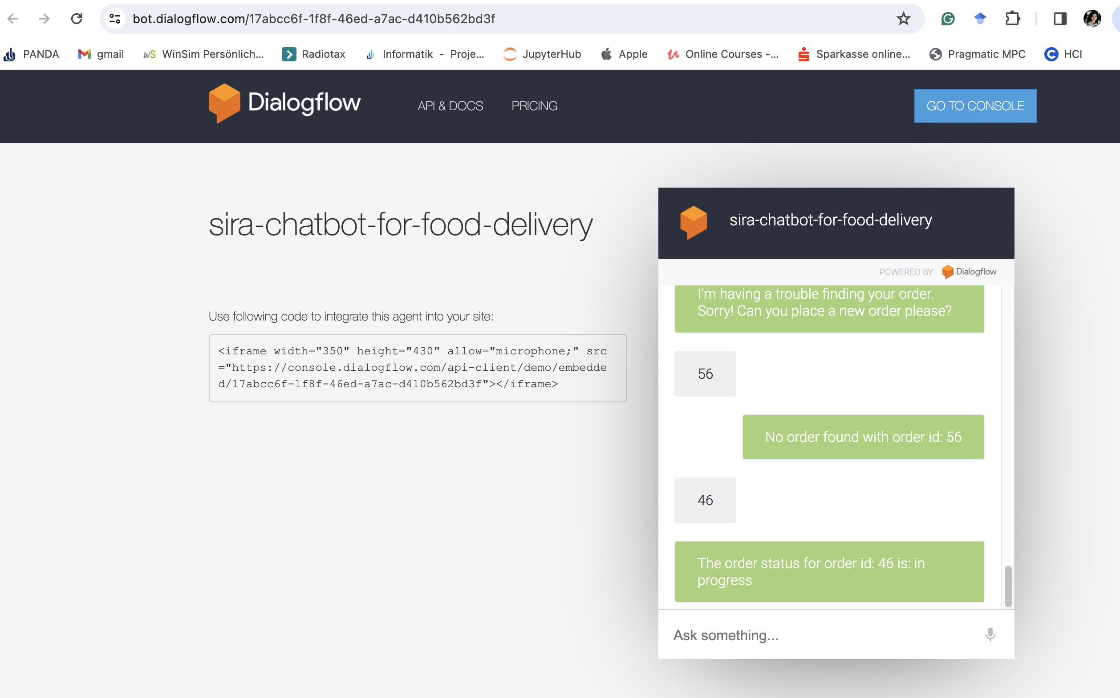

Check if all the process is working fine.

Website integration:

All the elements (photos, css-stylesheet, html file) required for website creation are present in the frontend folder.

Now navigate to the frontend folder and open home.html file.

Copy the url to integrate chatbot in this file.

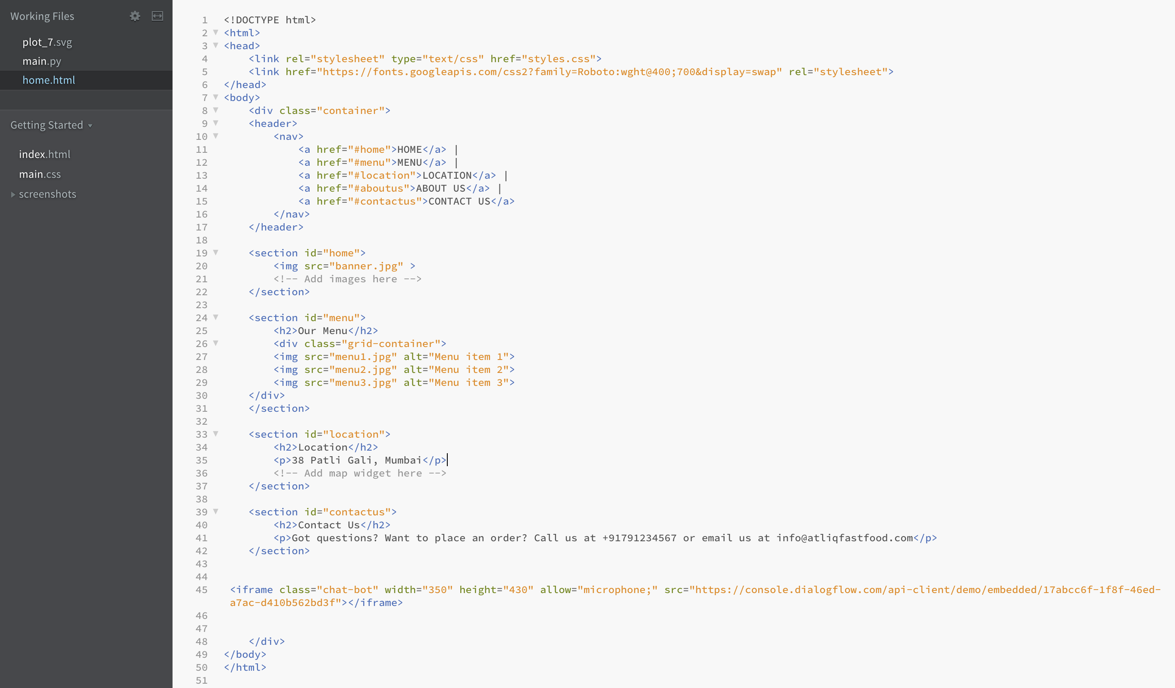

Now double-click this file from the folder. A chrome webpage will open with the chatbot.

